Accrete and Reform: Dual Mechanisms of Institutional Change in Online Communities

Abstract
How do online communities' governance structures evolve? We analyze 130,851 Reddit communities to test whether rule changes follow patterns predicted by punctuated equilibrium theory (PET), which predicts stability interrupted by comprehensive reforms, and institutional layering theory (ILT), which predicts gradual accumulation. Among the 5.3% of communities that modified rules between April and December 2020, systematic patterns emerged. Communities overwhelmingly add rather than remove rules (62% vs. 35%), supporting ILT, yet prefer bundled over incremental changes (66% vs. 34%), supporting PET. Critically, these dynamics interact: incremental changes consist almost exclusively of additions (83%), while bundled changes show substantially more deletions (39% vs. 12%). This reveals a sawtooth pattern of governance evolution—gradual upward layering of individual rules punctuated by comprehensive reforms where accumulated rules are pruned. Larger communities are more likely to change rules; older communities less so. Our findings demonstrate that digital governance follows sophisticated institutional patterns, with communities strategically balancing stability and adaptation through complementary mechanisms.
Keywords Digital Governance, Punctuated Equilibrium Theory, Institutional Layering, Social Media Policy, Rule Dynamics

Introduction
Online communities offer spaces where individuals worldwide connect over shared interests, exchange information, and engage in discussions (Kraut & Resnick, 2012; Wang et al., 2022). Platforms such as Reddit, Facebook groups, and Discord have fostered complex social ecosystems where norms and values are continually negotiated (Chandrasekharan et al., 2018). These spaces are characterized by a diverse array of user motivations and platform-specific affordances (Panek et al., 2018), creating significant challenges for maintaining order.
Online communities are widely understood as creating rules to manage user behavior (Kraut & Resnick, 2012; Fiesler et al., 2018; Kiene et al., 2025). As circumstances change, it stands to reason that their rules should change too. However, the mechanisms behind rule evolution remain understudied. This study tests hypotheses derived from two theories of policy development that, as Capano (2019) and Howlett and Mukherjee (2017) have noted, have shaped decades of institutional analysis. While punctuated equilibrium theory (PET) makes predictions about how often institutional changes are incremental versus bundled (Baumgartner & Jones, 2010), institutional layering theory (ILT) makes predictions about how often those changes come as added versus removed policies (Mahoney & Thelen, 2010). We perform text analysis on rule changes across 130,851 subreddit communities on the Reddit platform between two snapshots in April and December 2020.
The scale and complexity of these challenges have led to increased scholarly interest in the social design of online communities (Kraut & Resnick, 2012) and the broader platform governance frameworks that shape them (Gorwa, 2019). Current research on online community governance has explored various facets, including the creation of norms, enforcement of rules, and the influence of governance structures on community members (Kraut & Resnick, 2012; Reddy & Chandrasekharan, 2023). Prior work has examined the impact of Reddit's site-wide policies on hate speech, analyzing how top-down policy changes affect community behavior (Chandrasekharan et al., 2017). Other research has explored the types of norms and rules present within communities, categorizing them by target behaviors such as hate speech and harassment, finding that popular subreddits are more likely to have formal rules (Fiesler et al., 2018).
Despite these insights, Reddy and Chandrasekharan (2023) point out that existing work does not extensively examine temporal changes within a subreddit, specifically how and when different types of rules are added or changed. As online communities grow and evolve over time, their norms and rules often change to address new challenges, reflect shifting priorities, and respond to emerging issues (Chandrasekharan et al., 2018; Jhaver et al., 2019). Drawing from institutional analysis frameworks (Ostrom, 1990), online communities can be understood as self-governing institutions with their own governance structures (Frey et al., 2019), and various theories in policy analysis propose different mechanisms that drive policy change (Jenkins-Smith et al., 2014).
This paper explores how online communities develop their governance structures over time. We apply institutional analysis perspectives to online communities, drawing on policy analysis theories that propose different drivers of change. Specifically, this work addresses how two theories of policy development—punctuated equilibrium theory (PET) and institutional layering theory (ILT)—explain patterns of rule evolution. To understand their effects and interactions, we examine rule changes across 130,851 subreddit communities between two data "snapshots" taken in April and December 2020.ae
In this paper, we make four key contributions to communication, new media, and policy studies. First, we make a theoretical contribution by introducing and adapting two of the most important theories of rule change from policy studies (PET and ILT). Second, we make an empirical contribution by testing both theories in a large population of subreddits, offering generalizable insights into digital governance. This addresses critical questions about how online spaces maintain order and adapt to changing social dynamics in the absence of traditional institutional oversight (Gorwa, 2019; Massanari, 2015). Third, we provide empirical evidence that digital governance follows predictable patterns: communities primarily expand rules incrementally through single additions but undertake deletions through coordinated, bundled changes. By evaluating the predictions of PET and ILT side by side, our findings reveal that online spaces follow sophisticated patterns of self-organization that parallel traditional institutions in their adaptability and responsiveness to member needs (Fiesler et al., 2018). Fourth, building on work that has used online communities to study social organization (Panek et al., 2018; Shaw & Hill, 2014), we contribute back to policy studies by demonstrating how these spaces can serve as living laboratories for understanding broader patterns of collective decision-making in networked societies.

Related Work

Policy is a major avenue for the communication of structure in organizations, institutions, and communities. This includes communities that leverage new media to navigate new ways of relating. However, most policy scholarship is focused on nation-level policies. Fortunately, the field of policy studies is rich with theoretical frameworks for understanding the form, function, and mechanisms of policy systems generally. In this section, we introduce the literature on policy development outside of new media contexts and describe its implications for self-governance in online communities. Because online communities are simpler and numerous than the institutions typical of policy scholarship, our approach has the side effect of reciprocally advancing that literature as well, reinforcing the value of online communities for understanding organization generally.

Types of Policy Change
Policy changes range from minor modifications to comprehensive reforms (Frey & Schneider, 2023). Incremental adjustments involve small, continuous modifications aimed at fine-tuning existing policies without altering their fundamental principles (Lindblom, 1959). Small changes enable institutions to adapt gradually to evolving circumstances while maintaining stability. In contrast, larger transformations can entail substantial alterations or complete replacements of existing policies (Nalau & Handmer, 2015; Park et al., 2012; Baumgartner & Jones, 2009). These large-scale changes often occur in response to critical events or major shifts in the institutional environment that render existing policies inadequate or obsolete.
The specific actions taken to update policy content include additions, deletions, and modifications (Howlett & Migone, 2011; Reddy & Chandrasekharan, 2023). Additions involve incorporating new provisions to address emerging issues or fill identified gaps. Deletions involve removing outdated, irrelevant, or ineffective components. Modifications are alterations to existing rules to better align them with current needs. All three types reflect an institution's efforts to remain responsive, adaptable, and effective.

Theories of Rule Change
While online communities represent a relatively new form of social organization, they exhibit governance dynamics that parallel traditional institutions. Research has shown that these communities create formal rule systems to manage behavior, with larger subreddits being significantly more likely to have explicit, publicly posted rules (Fiesler et al., 2018; Kiene et al., 2025), and adapt their structures over time (Frey et al., 2022). Various theories in policy analysis propose different mechanisms that drive institutional change (Jenkins-Smith et al., 2014). Two prominent theories—punctuated equilibrium theory (PET) and institutional layering theory (ILT)—offer valuable insights into the dynamics of policy transformation. Whereas PET concerns the scale of policy changes over time, ILT is concerned with their direction (i.e., whether they make a policy system larger or smaller).

Punctuated Equilibrium Theory (PET)
PET posits that organizations alternate between periods of relative stability, characterized by incremental changes, and brief episodes of rapid change marked by "punctuations" (Baumgartner & Jones, 2010; Givel, 2010). The theory's intellectual origins lie in evolutionary biology, where Eldredge and Gould (1972) used punctuated equilibria to describe a fossil record characterized not by gradual, linear evolution but rather by long periods of stability interrupted by rapid speciation events. Baumgartner and Jones adapted this biological insight to the political world, arguing that policy systems similarly resist constant change, remaining in equilibrium until forces accumulate to produce fundamental shifts (Baumgartner & Jones, 2010).
In the context of policy systems, incremental changes refer to small, gradual adjustments that occur during periods of relative stability (Baumgartner & Jones, 2010). These changes are often minor and do not significantly alter overall organizational structure. In online community governance, incremental changes may involve small tweaks to existing rules, such as clarifying language or updating examples (see Fiesler et al., 2018 for a taxonomy of common rule types).
Punctuations, in contrast, are characterized by rapid and dramatic shifts that disrupt the existing equilibrium, fundamentally altering the policy landscape (Baumgartner & Jones, 2010; Givel, 2006; True et al., 2007). Punctuations occur when significant issues or pressures arise that cannot be adequately addressed through incremental changes alone. These disruptions can be triggered by exogenous shocks, changes in the external environment, or shifts in attention toward previously neglected issues (Baumgartner & Jones, 2010; Givel, 2006). In online communities, punctuations may manifest as substantial revisions to the rule system, the introduction of entirely new rules, or the removal of existing rules (Fiesler et al., 2018; Jhaver et al., 2019). These punctuations may be driven by major events, including endogenous crises such as the emergence of new types of disruptive behavior, or external pressures such as sudden influxes of new users (Kiene et al., 2016; Jhaver et al., 2019; Reddy & Chandrasekharan, 2023).
While PET offers valuable insights into the dynamics of stability and change, Givel (2010) notes that it says little about what type of changes happen during punctuations. PET does not directly address whether policy overhauls primarily involve adding new elements, removing outdated ones, or modifying existing structures. In the context of online communities, this limitation becomes particularly relevant: understanding whether rule punctuations manifest as additions, deletions, or modifications carries important implications for how digital governance evolves. If certain types of changes are rare and bundled, that may reflect that they require greater community-level consensus. This gap in PET's specification of change types opens the door for complementary perspectives.

Institutional Layering Theory (ILT)
Institutional layering theory, in contrast to PET's emphasis on abrupt shifts, focuses on the gradual evolution of institutions through the addition of new rules and structures atop existing ones (Thelen, 2004; Mahoney & Thelen, 2010; Streeck & Thelen, 2005). This process of layering allows for the coexistence of old and new elements within an institutional framework, leading to gradual transformation over time (Mahoney & Thelen, 2010).
Institutional layering is driven by several mechanisms. Streeck and Thelen (2005) emphasize gradual accumulation, in which small additions to policies build upon each other, eventually producing significant institutional change without dramatic disruption. A related but distinct mechanism involves strategic adaptation: when comprehensive reform is politically impossible or resource-constrained, actors add new policies to address emerging challenges while leaving existing structures intact to avoid opposition (Mahoney & Thelen, 2010). The layering perspective thus recognizes how institutions can evolve incrementally even when radical change is blocked by veto players or path dependencies (Fioretos et al., 2016; Schickler, 2001). This is particularly salient in contexts where political constraints or resource limitations prevent comprehensive institutional redesign (Hacker, 2004; van der Heijden, 2011).

Are PET and ILT Competing or Complementary?
Van der Heijden (2011) notes that the punctuated equilibrium literature lacks clear criteria for distinguishing major versus ordinary changes—a gap that becomes critical when comparing PET with ILT. While ILT describes ongoing gradual change through rule accumulation, these accumulated changes may eventually produce the kind of system-wide shifts that PET characterizes as punctuations (van der Heijden, 2011). This suggests the theories may describe the same phenomenon at different temporal scales: ILT captures the micro-process of change, while PET captures the macro-pattern.
However, ILT's primary focus on rules being added leaves a gap, as it does not fully account for rules being removed or revised (Capano, 2019). This limitation is significant because unchecked layering can lead to incoherence and inconsistency, as new elements are added without integration with existing structures (Howlett & Mukherjee, 2018). In practice, online communities periodically review and update their rule systems, removing outdated or redundant rules to maintain clarity. This pattern—accumulation followed by periodic pruning—suggests that pure layering may be unsustainable, eventually necessitating the comprehensive reorganization that PET predicts.
The key empirical question is whether incremental additions (ILT) and punctuated overhauls (PET) represent distinct, independent governance processes, or whether they influence each other in meaningful ways. To address the limitations in each theory and develop a more comprehensive understanding of policy dynamics in online communities, we propose considering PET and ILT together and examining their potential interactions.

Rule Dynamics in Online Communities
Rule development, observed across various institutional contexts, manifests distinctively in online communities. As these digital spaces grow and diversify, moderators may introduce new rules to address emerging forms of misconduct or to clarify acceptable behavior (Fiesler et al., 2018). These new rules may be appended to existing community guidelines, creating a more extensive governance framework. Similarly, as communities encounter novel situations or conflicts, moderators may add case-specific rules or exceptions, creating further layers of governance structures (Jhaver et al., 2019).
Specifically, this study seeks to answer the following research questions:
- RQ1: How do communities on Reddit change over time in terms of rule additions, deletions, and alterations?
- RQ2: Can existing theories—specifically punctuated equilibrium theory (PET) and institutional layering theory (ILT)—individually explain the observed patterns of rule changes in online communities?
Based on the theoretical frameworks reviewed above, we propose hypotheses that test the core predictions of each theory and their potential interaction.
ILT suggests that institutions evolve through gradual accumulation rather than wholesale replacement. The additive process enables organizations to remain flexible and responsive without the disruptions that might accompany extensive deletions or overhauls (Mahoney & Thelen, 2010). Additions may also be more politically expedient than deletions, as introducing new rules is often less contentious than removing existing ones that members have become accustomed to (Heinmiller, 2009). Furthermore, if rule changes are frequently reactions to specific new threats or emerging issues, communities might prefer to address them by adding new rules rather than altering or deleting existing policies (Streeck & Thelen, 2005). This leads to our first hypothesis:
- H1: Rule additions are more common than rule edits or rule deletions.
Similarly, PET emphasizes that institutional change is not continuous but episodic. Single changes are more manageable for both moderators and community members to implement and accept. Introducing one change at a time allows for easier communication and adaptation, minimizing confusion or resistance (Lindblom, 1959). Additionally, if rule changes are often responses to specific new threats, we might expect new rules to be added individually as they arise, rather than waiting to address multiple issues simultaneously in bundled updates (Baumgartner & Jones, 2009). Thus:
- H2: Single-rule ("incremental") changes are more common than multiple-rule ("bundled") changes.
Finally, we examine the interaction between the scale of change and rule dynamics. Based on the literature suggesting that layering (ILT) leads to complexity that eventually necessitates comprehensive reorganization (PET), we propose that these two theories describe complementary processes distinguished by the type of rule change. Under this framework, incremental changes primarily manifest as rule additions, consistent with ILT's layering mechanism, where institutions evolve through gradual accumulation of new elements to address emerging needs (Mahoney & Thelen, 2010). Conversely, bundled changes are expected to represent punctuated equilibrium moments characterized by disproportionately higher deletion rates. These moments serve as "housecleaning" episodes where accumulated inefficiencies trigger comprehensive reform, making it politically feasible to remove multiple outdated rules simultaneously (Baumgartner & Jones, 2009). This pattern implies that while communities predominantly evolve through layering, they utilize bundled changes to overcome the high barriers to rule removal (Streeck & Thelen, 2005), marking genuine punctuations within an otherwise incremental trajectory. This interaction suggests:
- H3: ILT and PET interact: Communities making bundled changes show a significantly higher proportion of deletions relative to additions compared to communities making incremental changes.

Methods

Empirical Setting
Reddit provides an ideal context for examining institutional dynamics in online communities. Reddit comprises millions of user-created communities called "subreddits. Each subreddit is focused on a specific topic that ranges from hobbies to professional interests (Fiesler et al., 2018). These communities operate with substantial autonomy under volunteer moderators who establish and enforce their own governance structures (Jhaver et al., 2019). Each subreddit can create formal rules using Reddit's "Rules Widget," introduced in 2017. This widget serves dual purposes: it displays rules to community members and integrates with Reddit's enforcement mechanisms, allowing moderators to cite specific rule violations when removing content or banning users (Chandrasekharan et al., 2018). That said, many communities also maintain rules through alternative means such as sidebar text or pinned posts—a practice particularly common among communities established before the widget's introduction (Fiesler et al., 2018). Our analysis focuses exclusively on rules formalized through the Rules Widget. As a result, this represents a subset of all community governance structures on Reddit.
Community rules on Reddit represent the institutional structures that govern user behavior and shape the overall functioning of communities (Fiesler et al., 2018). Reddit communities provide an ideal context to test the interaction between PET and ILT because they operate with substantial autonomy and independence under volunteer moderators who maintain order and facilitate beneficial user interactions by establishing and enforcing their own rule systems (Jhaver et al., 2019). As Reddit communities evolve, their rules undergo changes in response to various challenges and pressures, such as user growth, content moderation issues, and external events (Chandrasekharan et al., 2018; Jhaver et al., 2019), aligning with the theoretical assumptions of PET and ILT. These community-level changes manifest as additions of new rules, deletions, and modifications of existing rules, and occur either incrementally (single-rule changes) or in bundles (multiple-rule changes).

Data
We analyzed data from two snapshots of all subreddits with rules, captured in April and December 2020. These snapshots were derived from Reddit's public API and included all subreddits that had adopted the Rules Widget at both time points, yielding 180,376 subreddits in April 2020 and 175,609 in December 2020. A total of 169,260 communities appeared in both snapshots, forming our potential sample for longitudinal analysis. These communities collectively contained 525,018 rules in our dataset, counting each rule at each time point (i.e., a rule present at both snapshots contributes two observations). 525,018 rules across both observation periods.
Each snapshot contained comprehensive community-level metadata alongside detailed governance information from the Rules Widget. For each community, we recorded total count of rules, community age, subscriber count, and complete rule content with associated timestamps. Each rule has three components: a short name ("rule name"), a detailed description ("rule description"), and a violation reason ("violation reason"). Rules must be initialized with a name, but the description and violation reason fields may be left blank.
To ensure data quality and theoretical relevance for studying community governance dynamics, we applied several filters to the 169,260 communities present in both snapshots. First, we excluded 32,316 communities with fewer than three subscribers at either snapshot. These minimal-membership communities lack the basic social interaction necessary for meaningful governance pressures to emerge, as established in the literature on commons governance (Ostrom, 2000).
Second, we removed 4,891 communities founded within one month of our first snapshot to avoid conflating initial rule formation with genuine rule evolution. This ensured our analysis captured governance adaptation rather than initialization.
Finally, we excluded 1,202 communities with missing data essential to our analysis (i.e., rules widget information, age, or subscriber counts). This filtering procedure implicitly excluded communities whose rules were posted through alternative methods rather than the Rules Widget, a practice more common before the widget's widespread adoption.
The 130,851 communities in our final sample exhibited substantial variation in both size and governance complexity. Community sizes ranged from small groups to massive forums, with median subscriber counts increasing from 82 to 95 members between snapshots. The mean subscriber counts were considerably higher (23,502 to 26,232), reflecting the presence of several extremely large communities (the largest had 38.3 million subscribers in December 2020). Community ages ranged from newly established to 15.18 years old (Mdn = 1.85 years, M = 2.98 years, SD = 2.96).
Communities maintained relatively stable rule structures across the observation period. At both snapshots, the median community had 3 rules (April: M = 3.89, SD = 2.57; December: M = 3.94, SD = 2.61). Rule changes were remarkably rare: the median community maintained its complete rule set unchanged across the eight-month period. Among communities that did modify their governance, changes ranged from adding up to 15 new rules to removing up to 15 existing rules—reflecting Reddit's platform-imposed maximum of 15 rules per community (Kiene, 2024)—with a mean of only 0.047 rules changed per community.

Table 1. Most Reddit communities made no rule changes between April and December 2020, while a small subset engaged in substantial rule revisions.
Variable | M | SD | Mdn | Min | Max
Subscriber count (April 2020) | 23,501.69 | 423,660.57 | 82 | 0 | 36,440,855
Subscriber count (December 2020) | 26,231.87 | 441,586.22 | 95 | 0 | 38,255,392
Community age (months) | 35.7 | 35.51 | 22 | 1 | 183
Initial rule count | 3.89 | 2.57 | 3 | 1 | 15
Final rule count | 3.94 | 2.61 | 3 | 1 | 16
Rules added | 0.13 | 0.77 | 0 | 0 | 15
Rules modified | 0.01 | 0.09 | 0 | 0 | 5
Rules deleted | 0.07 | 0.57 | 0 | 0 | 15
Total changes | 0.21 | 1.27 | 0 | 0 | 30
Note. Descriptive statistics for 130,851 Reddit communities observed between April and December 2020. Median values indicate that the typical community experienced no rule changes during this period (Mdn = 0), although the distribution is highly skewed, with some communities making extensive additions, deletions, and modifications.

Change Categorization
We compared each rule across two time-stamped snapshots to determine whether—and how—it changed. We categorize changes into three types: additions, deletions, and edits. We treated creation timestamps as stable identifiers to distinguish true persistence from delete-and-recreate events. Rules present only in the second snapshot were coded as additions; rules present only in the first snapshot were coded as deletions. Rules that were present in both with different text were considered edits. To measure edits without including superficial formatting or spelling differences, we applied Levenshtein edit distance to rule names; rules differing by fewer than five characters were coded as unchanged, whereas rules exceeding that threshold were coded as edited (Levenshtein, 1966).
We construct two analytic datasets. The first includes all 130,851 communities to model the probability of any rule change (Part 1 of our two-part model). The second includes only the 6,948 communities that changed their rules, allowing us to examine change intensity and type distribution (Part 2). Out of 525,018 total rule-observations, 26,939 changed (5.13%)—with additions predominating (62.01%), followed by deletions (35.48%) and edits (2.51%). The remaining 498,079 rules (94.87%) were unchanged during the interval, which is expected over a relatively short window."
For each subreddit, we compared two snapshots and classified the ruleset delta as (a) unchanged (no rule additions, deletions, or edits), (b) incremental (exactly one rule-level change), or (c) bundled (more than one rule-level change).
Across 130,851 subreddits, 6,948 communities changed (5.3%), while 123,903 were unchanged (94.69%). Among the changed communities, most changes were bundled rather than isolated: 4,588 bundled (3.51% overall) versus 2,360 incremental (1.80% overall). Within the changed subset, additions were far more prevalent than deletions or textual edits.
For bundled communities, which averaged 5.36 total changes per community (SD = 4.25), we identified the "dominant change type" as the category (additions, deletions, or modifications) that occurred most frequently within that community. On average, bundled communities made 3.21 additions (SD = 2.55), 2.03 deletions (SD = 2.27), and only 0.11 modifications (SD = 0.41) per community. Communities where no single type constituted a clear majority were classified as having "no dominant type" (n = 1,520, representing 33.1% of bundled communities). This operationalization allowed us to examine whether certain types of changes tend to cluster together when communities undertake rule reform.

Results

Communities Primarily Evolve through Rule Additions.
Among communities that modified their rules, additions dominated. Of the 26,939 total rule changes observed, 16,705 (62%) were additions, 9,558 (35.5%) were deletions, and only 676 (2.5%) were modifications.
This pattern holds at the community level. We classified each community as "addition-dominant" if additions constituted more than half of its rule changes, then tested whether the proportion of addition-dominant communities exceeds 50%. A one-sided binomial test confirmed it does (p < .001), with 81-100% of changing communities being addition-dominant (95% CI). Paired comparisons reinforced this finding: the median number of additions (1.0) exceeded both modifications (0.0) and deletions (1.0), with Wilcoxon signed-rank tests significant after Bonferroni correction (W = 20,984,177, p < .001 for additions vs. modifications; W = 12,042,764.5, p < .001 for additions vs. deletions). These results strongly support H1: communities favor additions over other change types.
The tendency toward accumulation appears robust across community characteristics. Small and large communities alike were addition-dominant (82% to 88%), as were new and mature communities (83% to 87%). The median community devoted two-thirds of its changes to additions, with 43% devoting more than three-quarters. This pattern of regulatory accumulation aligns with institutional layering theory, which holds that organizations add new elements rather than remove or fundamentally alter existing structures—possibly because eliminating established rules carries political and social costs (Mahoney & Thelen, 2010).

Figure 1. Rule changes are overwhelmingly additive, consistent with institutional layering.
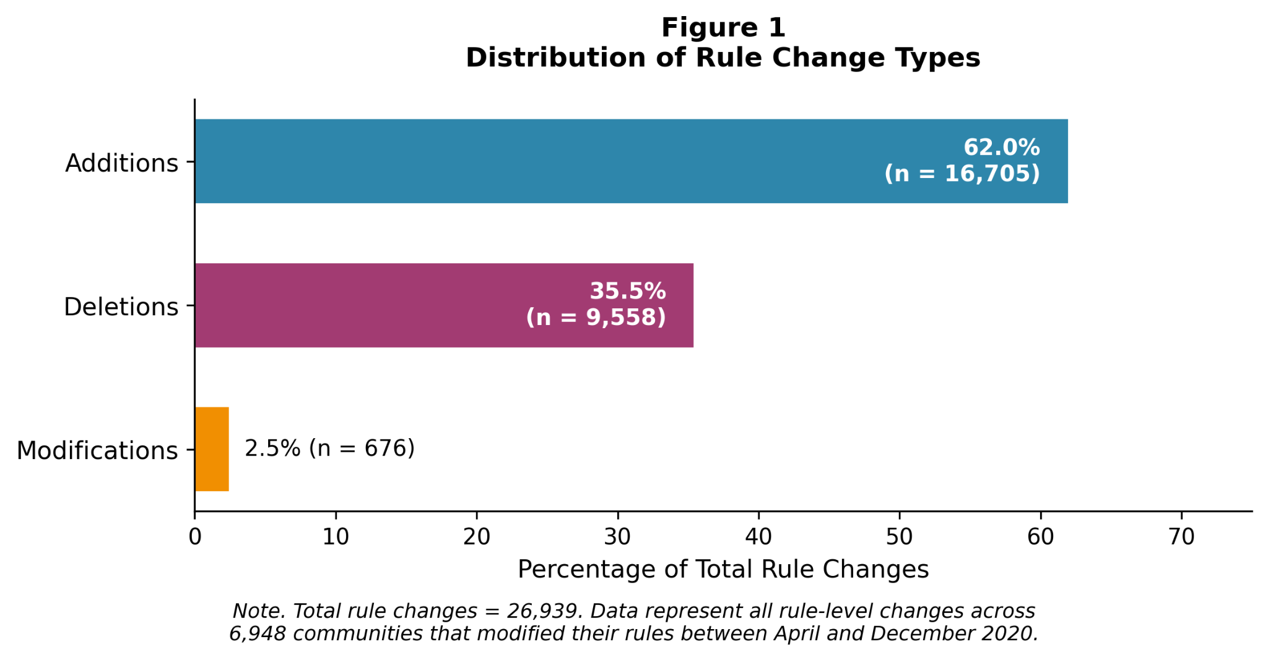
Note. Percentages are calculated over all rule-level changes observed between April and December 2020 among the 6,948 communities that changed rules. Additions account for 62% of changes (16,705), deletions for 35.5% (9,558), and modifications for 2.5% (676).

Communities Undergo Bundled (Multiple-Rule) Changes over Incremental (Single-Rule) Changes
When communities modify their rules, they tend to make multiple changes at once. Of the 6,948 communities that changed their rules, only 2,360 (34%) made a single change, while 4,588 (66%) implemented bundled changes involving two or more rules simultaneously. The median changing community modified two rules, with 25% changing five or more at once.
A binomial test found no support for the hypothesis that incremental changes would be more common; bundled changes significantly predominated (p < .001). Bootstrap analysis (10,000 iterations) confirmed this finding: the proportion of incremental changes lay between 32.9% and 35.1% (95% CI), consistently below the 50% threshold. Not a single bootstrap sample showed incremental changes exceeding bundled ones.
The distribution also showed significant overdispersion (dispersion index = 4.18, p < .001), indicating that rule changes cluster more than would be expected if they occurred independently. When communities decide to modify their governance structures, they tend to address multiple issues simultaneously rather than making isolated adjustments.

Figure 2. Rule changes are more often bundled than incremental, suggesting governance revisions occur in bursts rather than isolated tweaks.
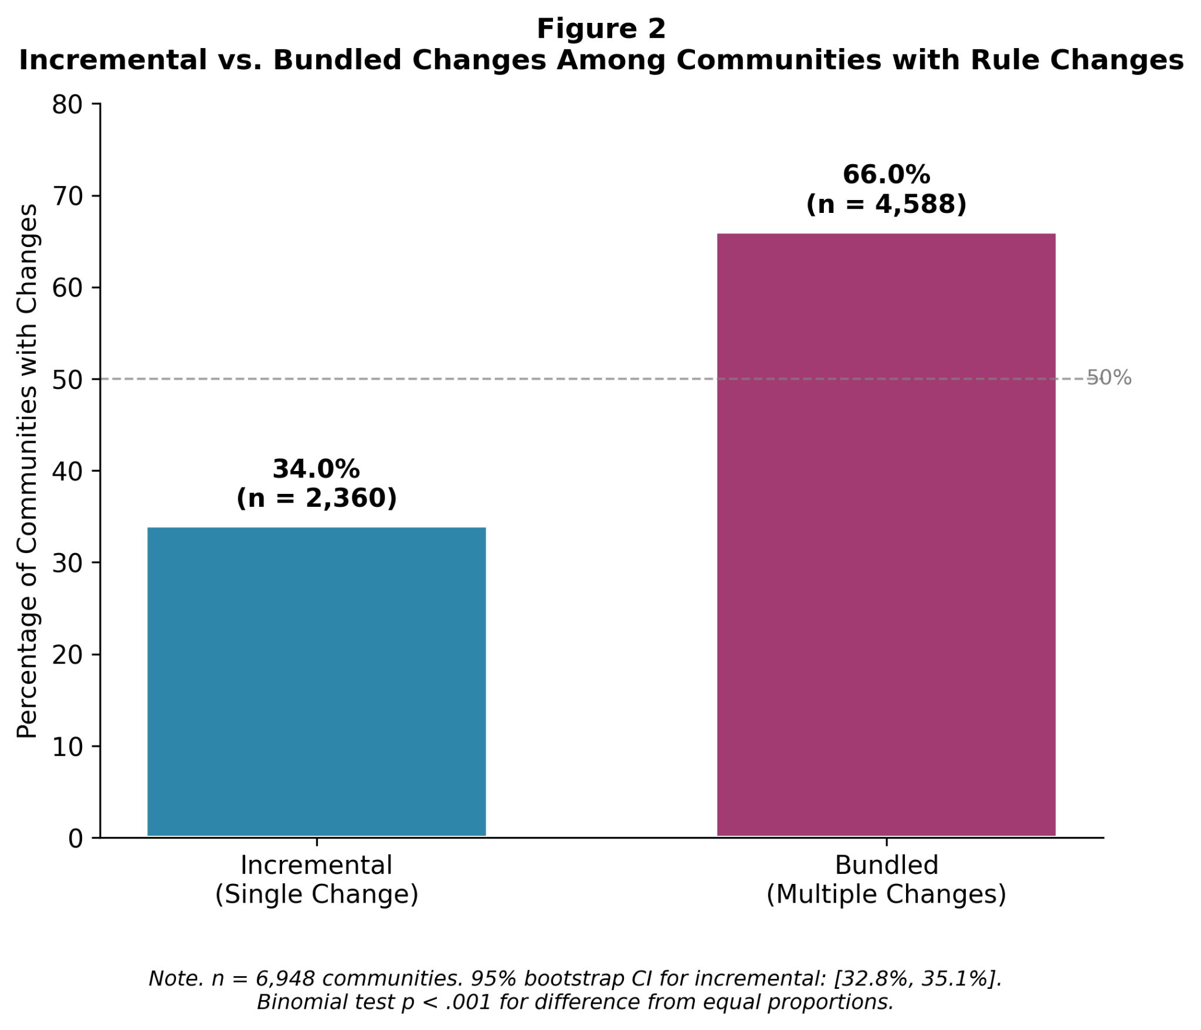
Note. Among the 6,948 communities that changed rules between April and December 2020, 66% made bundled changes (two or more rule-level changes; n = 4,588) and 34% made incremental changes (exactly one change; n = 2,360). The predominance of bundled events is consistent with punctuated accounts in which governance change arrives in concentrated bursts rather than as steady, one-at-a-time adjustments (p < .001; bootstrap 95% CI for incremental share = 32.9%-35.1%).

Bundled Changes Reveal Punctuated Reforms within Dominant Layering Patterns
The relationship between change type and change scale reveals how institutional layering and punctuated equilibrium operate together. When communities add rules without making deletions or modifications, 70.2% do so one rule at a time (p < .001), suggesting that pure additions tend to be incremental. Deletions and modifications, however, almost always occur as part of broader reform efforts—consistent with punctuated equilibrium theory, which holds that institutional change often occurs in bursts rather than through continuous incremental adjustment (Baumgartner & Jones, 2009).
To test whether the balance between additions and deletions varies by scale of change, we compared incremental communities (single changes) with bundled communities (multiple changes). Among incremental communities (n = 2,360), 83.0% added a rule while only 10.1% deleted one (6.9% modified). This 8-to-1 ratio exemplifies institutional layering: communities choose to add rather than remove when making isolated changes. The pattern shifts in bundled communities (n = 4,588): additions drop to 62.3% while deletions rise to 35.1%. Though additions still outnumber deletions, the ratio narrows to less than 2-to-1.
This shift is best understood through the deletion-to-addition ratio. In incremental communities, deletions comprise 10.8% of combined additions and deletions (238 deletions vs. 1,958 additions). In bundled communities, this proportion nearly triples to 39%. A chi-square test confirmed that these proportions differ significantly, χ²(1) = 561.97, p < .001.
The pattern persists regardless of bundle size: communities making two changes show 34% deletions; those making six or more show 39%—both consistently higher than the 10% in single-change communities. Rule edits remain rare throughout, comprising under 7% of incremental changes and under 3% of bundled changes, suggesting communities prefer clear additions or removals over modifying existing text.
These findings support H3. Online communities combine two distinct modes of institutional change: governance predominantly evolves through incremental layering—adding single rules to address emerging needs—while bundled changes represent punctuated moments where barriers to rule removal are temporarily lowered. Communities use these moments to clear accumulated "regulatory debris" while introducing new structures. Rather than adhering to pure layering or pure punctuation, communities exhibit a hybrid pattern in which gradual accumulation is periodically interrupted by comprehensive reforms.

Figure 3. Sawtooth governance: incremental layering is overwhelmingly additive, but punctuated (bundled) reforms sharply increase deletions.
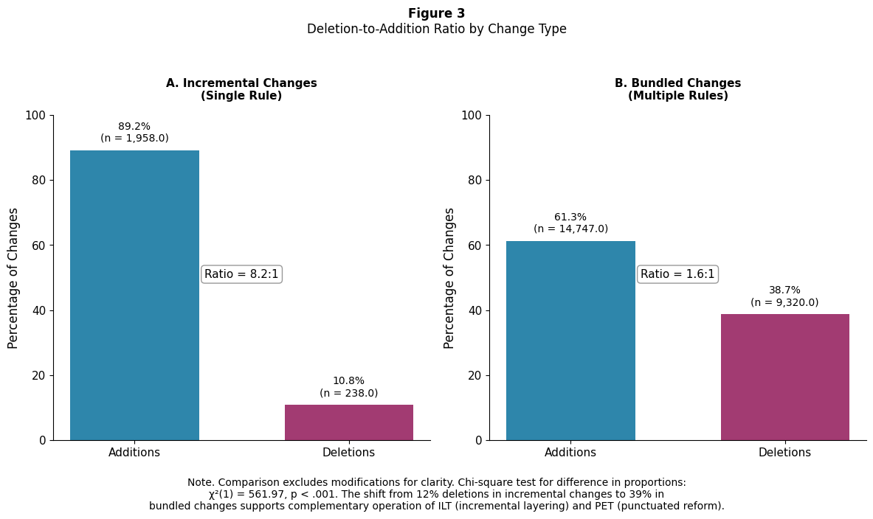
Note. Comparison excludes modifications for clarity. In incremental (single-change) communities, deletions constitute 10.8% of additions+deletions (238 deletions vs. 1,958 additions; deletion-to-addition ratio ≈ 1:8.2). In bundled (multi-change) communities, deletions rise to 39% (9,320 deletions vs. 14,747 additions; ratio ≈ 1:1.6). These proportions differ significantly, χ²(1) = 561.97, p < .001, consistent with incremental ILT-style accumulation punctuated by PET-style reform episodes where rule removal becomes more common.

Figure 4. Single-change updates are addition-dominant (layering), while larger bundles become increasingly mixed and deletion-including (reform episodes).
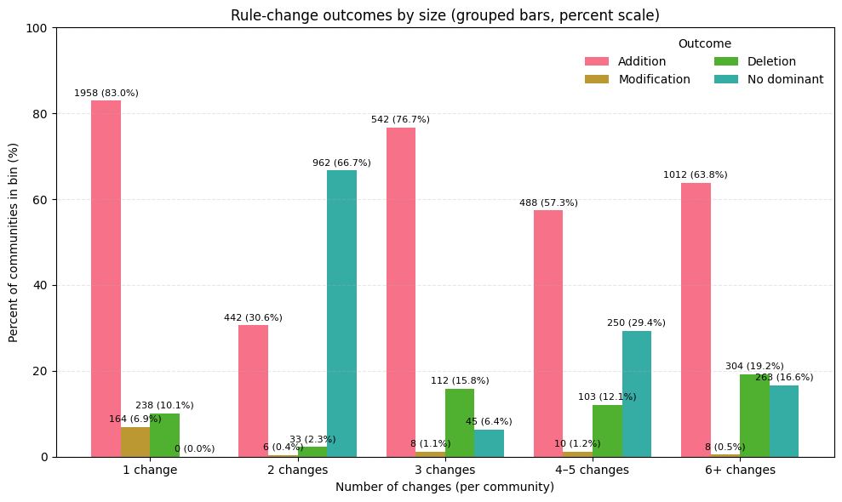
Note. n = 6,948 communities that changed rules between April and December 2020. Bars show the percentage of communities in each change-count bin classified by dominant change type (addition, deletion, modification) or no dominant (no single type forms a majority). Single-change communities are overwhelmingly addition-dominant (83.0%), consistent with incremental layering. As bundle size increases (3, 4-5, 6+ changes), addition-dominance declines (e.g., 76.7% at 3 changes to 63.8% at 6+), while deletion-dominance and "no dominant" increase—consistent with punctuated reform episodes involving more rule removal. The "no dominant" peak at 2 changes reflects a mechanical artifact: with exactly two changes, mixed pairs (e.g., one addition + one deletion) necessarily yield no dominant category.

Community Size, Age, and Complexity Shape the Likelihood of Governance Evolution
In all analyses, the unit of analysis is the community. Given the skewed distribution of our outcome variable—94.7% of communities made no rule changes while 5.3% made between 1 and 30 changes—we employed a two-part hurdle model (Mullahy, 1986; Cameron & Trivedi, 2013). The first part uses logistic regression to model the probability of any rule change; the second part uses negative binomial regression on communities that changed (n = 6,948) to model change intensity. We report odds ratios (OR) for Part 1 and incidence rate ratios (IRR) for Part 2. Model comparison details appear in Appendix A; results appear in Table 2.
Community size emerges as the strongest predictor. Each doubling of subscriber count increases the odds of making any change by 40% (OR = 1.40, p < .001) and, among changers, increases the expected number of changes by 24% (IRR = 1.24, p < .001). This reflects governance pressures accompanying growth: expanding communities encounter novel situations and diverse behaviors that existing rules may not address (Kiene et al., 2016; Jhaver et al., 2019).
Community age acts as a stabilizing force. Each doubling of age reduces change probability by 18% (OR = 0.82, p < .001) and, among changers, reduces intensity by 13% (IRR = 0.87, p < .001). This effect persists after controlling for size and complexity, suggesting institutional inertia develops through norm consensus and established precedents (Ostrom, 2000).
Existing rule complexity also predicts change: each additional rule increases the odds of modification by 10% (OR = 1.10, p < .001) and associates with 19% more changes among changers (IRR = 1.19, p < .001)—consistent with institutional layering theory (Mahoney & Thelen, 2010). Interaction effects appear only in Part 2, where the negative size × rule count interaction (IRR = 0.99, p < .001) suggests a saturation dynamic: communities with elaborate rule systems show diminished responsiveness to growth pressures.

Table 2 Hurdle Model Results: Predictors of Rule Change (N = 130,851)
Part 1: Logistic Regression—Probability of Any Change
Predictor | B | SE | IRR | 95% CI
Intercept | -4.321*** | 0.139 | 0.013 | [0.01, 0.02]
Log(Subscribers)ᵃ | 0.337*** | 0.019 | 1.4 | [1.35, 1.45]
Log(Community Age)ᵇ | -0.203*** | 0.042 | 0.817 | [0.75, 0.89]
Initial Rule Count | 0.097*** | 0.017 | 1.102 | [1.06, 1.14]
Log(Subscribers) × Rules | -0.001 | 0.002 | 0.999 | [0.996, 1.00]
Log(Age) × Rules | 0.003 | 0.005 | 1.003 | [0.99, 1.01]
Log(Subscribers) × Log(Age) | 0.004 | 0.005 | 1.004 | [0.99, 1.01]
Model fit: Pseudo-R² = .094; Log-Likelihood = -29,041; AIC = 58,096; AUC = 0.732
Part 2: Negative Binomial Regression—Intensity of Change (n = 6,948 changers)
Predictor | B | SE | IRR | 95% CI
Intercept | 0.509*** | 0.05 | 1.663 | [1.51, 1.83]
Log(Subscribers) | 0.212*** | 0.006 | 1.236 | [1.22, 1.25]
Log(Community Age) | -0.137*** | 0.015 | 0.872 | [0.85, 0.90]
Initial Rule Count | 0.175*** | 0.005 | 1.191 | [1.18, 1.20]
Log(Subscribers) × Rules | -0.008*** | 0 | 0.992 | [0.99, 0.99]
Log(Age) × Rules | 0.003** | 0.001 | 1.003 | [1.00, 1.01]
Log(Subscribers) × Log(Age) | 0.004* | 0.002 | 1.004 | [1.00, 1.01]
Alpha (dispersion) | 0.005*** | 0.001 | — | —
Model fit: Pseudo-R² = .228; Log-Likelihood = -21,628; AIC = 43,272
Larger communities make more rule changes, older communities make fewer, and existing rule complexity weakens the size effect. The hurdle model separates the decision to change (Part 1) from the intensity of change among communities that modified rules (Part 2). OR = Odds Ratio; IRR = Incidence Rate Ratio. Combined model AIC (101,368) is substantially lower than single negative binomial AIC (121,565), indicating superior fit for the two-part specification.
ᵃLog-transformed subscriber count from April 2020 snapshot.
ᵇLog-transformed community age in months.
*p < .05. **p < .01. ***p < .001.

Discussion
Our analysis of 130,851 Reddit communities reveals distinct patterns of rule evolution that both support and extend existing theories of institutional change.

Reconciling Punctuated Equilibrium and Institutional Layering
The data present an apparent paradox: communities overwhelmingly add rules, supporting institutional layering theory (ILT), yet prefer bundled over incremental changes, aligning with punctuated equilibrium theory (PET). This tension resolves when we consider the interaction between change type and scale.
Single-rule changes reflect the incremental process described by ILT—addressing emergent needs without overhauling existing policies (Mahoney & Thelen, 2010). The increased occurrence of deletions during bundled changes, by contrast, aligns with PET's notion of punctuated shifts. Removing established rules requires overcoming status quo bias and resistance from members accustomed to existing structures (van der Heijden, 2011; Heinmiller, 2009). The coordination and consensus this demands may explain why deletions typically occur in concentrated bursts rather than as isolated events.
These results suggest a hybrid model of institutional evolution. Rather than competing, PET and ILT describe complementary mechanisms operating under different conditions: incremental changes capture the gradual accumulation predicted by ILT, whereas bundled changes constitute the punctuated reforms emphasized by PET (Gersick, 1991; Romanelli & Tushman, 1994). The critical insight is that deletions—the most disruptive governance changes—require the coordination characteristic of punctuated equilibrium events. Beyond layering, Thelen's concept of drift may help explain why communities eventually undertake bundled deletions: rules whose original purposes have shifted require wholesale recalibration (Thelen, 2004; Hacker, 2004). ILT and PET thus function as complementary mechanisms within a broader typology of institutional change (Capano, 2019; Mahoney & Thelen, 2010).

The Adaptive Capacity of Digital Governance
Community size emerges as the strongest predictor of rule change, confirming that growth creates governance pressures requiring institutional response (Frey et al., 2019). The robust negative age effect supports theories of institutional development in which communities evolve toward stable governance equilibria through norm crystallization and precedent establishment (Ostrom, 2000; Thelen, 2004). Rather than becoming inflexible, communities with extensive rule systems develop what we term "adaptive bureaucracy"—maintaining stability while retaining capacity for periodic comprehensive reform. This aligns with research showing that institutionalized processes can facilitate rather than hinder adaptation (Imperial et al., 2016; Emerson et al., 2011).

Limitations
Our filtering criteria may introduce selection bias by overrepresenting established, formally governed communities while excluding those managing rules through alternative means (Fiesler et al., 2018; Seering et al., 2019). Excluding communities founded within one month of the first snapshot removes insights into initial rule formation (Kiene et al., 2016).
Our two-snapshot approach (April to December 2020) assumes that multiple rule changes represent coordinated reform events rather than sequential incremental changes. While evidence supports this assumption—including the rarity of changes (5.3%) and patterns suggesting all-or-nothing reform—we cannot definitively establish timing within the observation period. The COVID-19 pandemic may also have influenced governance patterns, potentially limiting generalizability.
The two-part model explains 9.4% of variation in change probability and 22.8% of variation in change intensity among changers. Substantial unexplained variation likely reflects unmeasured factors such as community topic, moderator characteristics (Jhaver et al., 2019), or platform-wide policy changes (Chandrasekharan et al., 2017). Finally, Reddit's specific features may limit generalizability to other platforms (Seering et al., 2019).

Conclusion
Our analysis reveals that Reddit community rule changes follow systematic patterns driven by the interplay of growth pressures, temporal stabilization, and institutional complexity. The finding that change responds to growth and that existing complexity begets further elaboration—particularly through rule additions—aligns with institutional layering theory (Mahoney & Thelen, 2010; Streeck & Thelen, 2005). At the same time, the extreme rarity of changes (5.3% of communities) combined with patterns of comprehensive, mixed reforms strongly supports punctuated equilibrium theory (Baumgartner & Jones, 2010).
Communities deploy these strategies differently depending on developmental stage and social context: some adapt primarily through gradual layering, others through punctuated reforms. These findings contribute to understanding how online communities navigate the fundamental tension between institutional stability and adaptive flexibility in their governance evolution.

Appendix A
The hurdle model specification provides substantially better fit than a single-equation count model (combined hurdle AIC = 101,368 vs. single negative binomial AIC = 121,565; BIC difference = 20,150). The two-part structure aligns with organizational theory suggesting that barriers to initiating change differ from factors driving change magnitude once the decision to change has been made (March, Schulz, & Zhou, 2000). In Part 1, OR > 1 indicates increased probability of change. In Part 2, IRR > 1 indicates more changes per reform episode; the negative binomial specification accounts for overdispersion in the count data.

Code & Data:
https://bit.ly/github_reddit-rule-change
https://bit.ly/github_CommunityRuleChange

References
Baumgartner, F. R., & Jones, B. D. (2010). Agendas and instability in American politics (2nd ed.). University of Chicago Press.
Baumgartner, F. R., Breunig, C., Green-Pedersen, C., Jones, B. D., Mortensen, P. B., Nuytemans, M., & Walgrave, S. (2009). Punctuated equilibrium in comparative perspective. American Journal of Political Science, 53(3), 603-620. https://doi.org/10.1111/j.1540-5907.2009.00389.x
Capano, G. (2019). Reconceptualizing layering—From mode of institutional change to mode of institutional design: Types and outputs. Public Administration, 97(3), 590-604. https://doi.org/10.1111/padm.12583
Chandrasekharan, E., Pavalanathan, U., Srinivasan, A., Glynn, A., Eisenstein, J., & Gilbert, E. (2017). You can’t stay here: The efficacy of Reddit’s 2015 ban examined through hate speech. Proceedings of the ACM on Human-Computer Interaction, 1(CSCW), 1-22. https://doi.org/10.1145/3134666
Chandrasekharan, E., Samory, M., Jhaver, S., Charvat, H., Bruckman, A., Lampe, C., Eisenstein, J., & Gilbert, E. (2018). The internet’s hidden rules: An empirical study of Reddit norm violations at micro, meso, and macro scales. Proceedings of the ACM on Human-Computer Interaction, 2(CSCW), 32:1-32:25. https://doi.org/10.1145/3274301
Cameron, A. C., & Trivedi, P. K. (2013). Regression analysis of count data (2nd ed.). Cambridge University Press.
Eldredge, N., & Gould, S. J. (1972). Punctuated equilibria: An alternative to phyletic gradualism. In T. J. M. Schopf (Ed.), Models in paleobiology (pp. 82-115). Freeman Cooper.
Emerson, K., Nabatchi, T., & Balogh, S. (2011). An integrative framework for collaborative governance. Journal of Public Administration Research and Theory, 22(1), 1-29.
Fiesler, C., Jiang, J. A., McCann, J., Frye, K., & Brubaker, J. R. (2018). Reddit rules! Characterizing an ecosystem of governance. Proceedings of the International AAAI Conference on Web and Social Media, 12(1), 72-81.
Fioretos, O., Falleti, T. G., & Sheingate, A. (Eds.). (2016). The Oxford handbook of historical institutionalism. Oxford University Press.
Frey, S., Krafft, P. M., & Keegan, B. C. (2019). " This Place Does What It Was Built For" Designing Digital Institutions for Participatory Change. Proceedings of the ACM on human-computer interaction, 3(CSCW), 1-31. https://doi.org/10.1145/3359134
Frey, S., & Schneider, N. (2023). Effective voice: Beyond exit and affect in online communities. New Media & Society, 25(9), 2381-2398. https://doi.org/10.1177/14614448211044025
Frey, S., Zhong, Q., Bulat, B., Weisman, W. D., Liu, C., Fujimoto, S., Wang, H., & Schweik, C. M. (2022). Governing online goods: Maturity and formalization in Minecraft, Reddit, and World of Warcraft communities. Proceedings of the ACM on Human-Computer Interaction, 6(CSCW2), 1-23. https://doi.org/10.1145/3555191
Gersick, C. J. G. (1991). Revolutionary change theories: A multilevel exploration of the punctuated equilibrium paradigm. Academy of Management Review, 16(1), 10-36. https://doi.org/10.5465/amr.1991.4278988
Givel, M. (2006). Punctuated equilibrium in limbo: The tobacco lobby and U.S. state policymaking from 1990 to 2003. Policy Studies Journal, 34(3), 405-418. https://doi.org/10.1111/j.1541-0072.2006.00179.x
Givel, M. (2010). The evolution of the theoretical foundations of punctuated equilibrium theory in public policy. Review of Policy Research, 27(2), 187-198. https://doi.org/10.1111/j.1541-1338.2009.00437.x
Gorwa, R. (2019). What is platform governance? Information, Communication & Society, 22(6), 854-871. https://doi.org/10.1080/1369118X.2019.1573914
Hacker, J. S. (2004). Privatizing risk without privatizing the welfare state: The hidden politics of social policy retrenchment in the United States. American Political Science Review, 98(2), 243-260. https://doi.org/10.1017/S0003055404001121
Heinmiller, B. T. (2009). Path dependency and collective action in common-pool governance. International Journal of the Commons, 3(1), 131-147. https://doi.org/10.18352/ijc.79
Howlett, M., & Migone, A. (2011). Charles Lindblom is alive and well and living in punctuated equilibrium land. Policy and Society, 30(1), 53-62. https://doi.org/10.1016/j.polsoc.2010.12.006
Howlett, M., & Mukherjee, I. (2017). Policy formulation: Where knowledge meets power in the policy process. In M. Howlett & I. Mukherjee (Eds.), Handbook of policy formulation (pp. 3-22). Edward Elgar Publishing.
Howlett, M., & Mukherjee, I. (Eds.). (2018). Routledge handbook of policy design. Routledge.
Imperial, M. T., Johnston, E., Pruett-Jones, M., Leong, K., & Thomsen, J. (2016). Sustaining the useful life of network governance: Life cycles and developmental challenges. Frontiers in Ecology and the Environment, 14(3), 135-144.
Jenkins-Smith, H. C., Nohrstedt, D., Weible, C. M., & Sabatier, P. A. (2014). The advocacy coalition framework: Foundations, evolution, and ongoing research. In P. A. Sabatier & C. M. Weible (Eds.), Theories of the policy process (3rd ed., pp. 183-224). Westview Press.
Jhaver, S., Birman, I., Gilbert, E., & Bruckman, A. (2019). Human-machine collaboration for content regulation: The case of Reddit Automoderator. ACM Transactions on Computer-Human Interaction, 26(5), 31:1-31:35. https://doi.org/10.1145/3338243
Kiene, C. (2024). Identity, legitimacy, and voice: Understanding rule adoption, compliance, and evolution in online communities (Publication No. 31761162) [Doctoral dissertation, University of Washington]. ProQuest Dissertations & Theses Global.
Kiene, C., Hwang, S., TeBlunthuis, N., Colglazier, C., Shaw, A., & Hill, B. M. (2025). The Relational Origins of Rules in Online Communities (No. arXiv:2505.18318). arXiv. https://doi.org/10.48550/arXiv.2505.18318
Kiene, C., Monroy-Hernández, A., & Hill, B. M. (2016). Surviving an "Eternal September": How an online community managed a surge of newcomers. Proceedings of the 2016 CHI Conference on Human Factors in Computing Systems, 1152-1156. https://doi.org/10.1145/2858036.2858356
Kraut, R. E., & Resnick, P. (2012). Building successful online communities: Evidence-based social design. MIT Press.
Levenshtein, V. I. (1966). Binary codes capable of correcting deletions, insertions, and reversals. Soviet Physics-Doklady, 10(8), 707-710.
Lindblom, C. E. (1959). The science of "muddling through." Public Administration Review, 19(2), 79-88. https://doi.org/10.2307/973677
Mahoney, J., & Thelen, K. (Eds.). (2010). Explaining institutional change: Ambiguity, agency, and power. Cambridge University Press.
March, J. G., Schulz, M., & Zhou, X. (2000). The dynamics of rules: Change in written organizational codes. Stanford University Press.
Massanari, A. (2015). #Gamergate and The Fappening: How Reddit’s algorithm, governance, and culture support toxic technocultures. New Media & Society, 19(3), 329-346. https://doi.org/10.1177/1461444815608807
Mullahy, J. (1986). Specification and testing of some modified count data models. Journal of Econometrics, 33(3), 341-365. https://doi.org/10.1016/0304-4076(86)90002-3
Nalau, J., & Handmer, J. (2015). When is transformation a viable policy alternative? Environmental Science & Policy, 54, 349-356. https://doi.org/10.1016/j.envsci.2015.07.022
Ostrom, E. (1990). Governing the commons: The evolution of institutions for collective action. Cambridge University Press.
Ostrom, E. (2000). Collective action and the evolution of social norms. Journal of Economic Perspectives, 14(3), 137-158. https://doi.org/10.1257/jep.14.3.137
Panek, E., Hollenbach, C., Yang, J., & Rhodes, T. (2018). The effects of group size and time on the formation of online communities: Evidence from Reddit. Social Media + Society, 4(4). https://doi.org/10.1177/2056305118815908
Park, S. E., Marshall, N. A., Jakku, E., Dowd, A. M., Howden, S. M., Mendham, E., & Fleming, A. (2012). Informing adaptation responses to climate change through theories of transformation. Global Environmental Change, 22(1), 115-126. https://doi.org/10.1016/j.gloenvcha.2011.10.003
Reddy, H., & Chandrasekharan, E. (2023). Evolution of Rules in Reddit Communities. Computer Supported Cooperative Work and Social Computing, 278-282. https://doi.org/10.1145/3584931.3606973
Romanelli, E., & Tushman, M. L. (1994). Organizational transformation as punctuated equilibrium: An empirical test. Academy of Management Journal, 37(5), 1141-1166. https://doi.org/10.5465/256669
Schickler, E. (2001). Disjointed pluralism: Institutional innovation and the development of the U.S. Congress. Princeton University Press.
Seering, J., Wang, T., Yoon, J., & Kaufman, G. (2019). Moderator engagement and community development in the age of algorithms. New Media & Society, 21(7), 1417-1443. https://doi.org/10.1177/1461444818821316
Shaw, A., & Hill, B. M. (2014). Laboratories of oligarchy? How the iron law extends to peer production. Journal of Communication, 64(2), 215-238. https://doi.org/10.1111/jcom.12082
Streeck, W., & Thelen, K. (2005). Beyond continuity: Institutional change in advanced political economies (Vol. 19). Oxford University Press.
Thelen, K. (2004). How institutions evolve: The political economy of skills in Germany, Britain, the United States, and Japan. Cambridge University Press. https://doi.org/10.1017/CBO9780511790997
True, J. L., Jones, B. D., & Baumgartner, F. R. (2007). Punctuated equilibrium theory. In P. Sabatier (Ed.), Theories of the policy process (2nd ed., pp. 155-188). Westview Press.
van der Heijden, J. (2011). Institutional layering: A review of the use of the concept. Politics, 31(1), 9-18. https://doi.org/10.1111/j.1467-9256.2010.01397.x
Wang, H. M., Bulat, B., Fujimoto, S., & Frey, S. (2022). Governing for free: Rule process effects on Reddit moderator motivations. In C. Stephanidis, M. Antona, S. Ntoa, & G. Salvendy (Eds.), HCI International 2022 - Late breaking posters (Vol. 1655, pp. 97-105). Springer Nature Switzerland.

